REQUEST FOR PROPOSAL

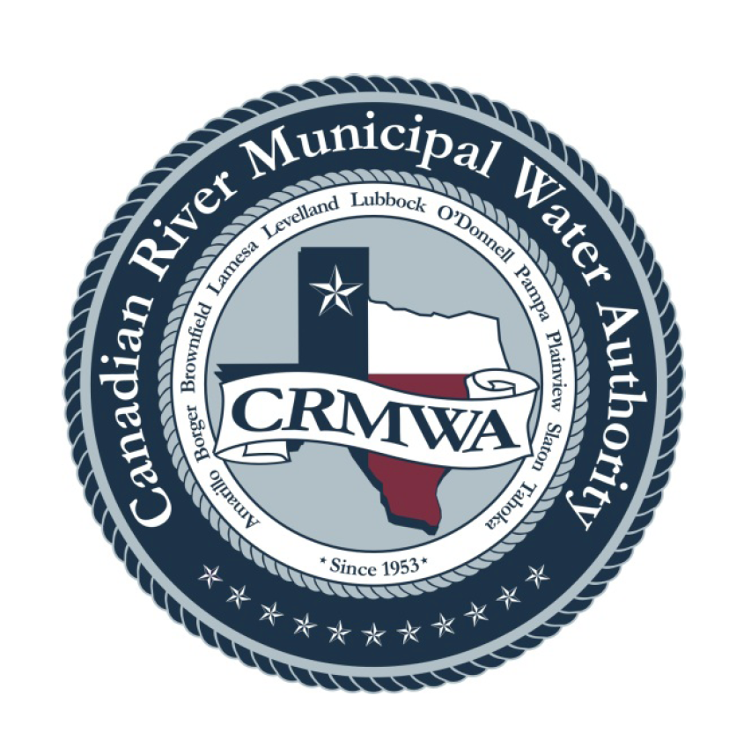
Canadian River Municipal Water Authority

RFP NO: 0901-2026

Enterprise Resource Planning (ERP) Consulting Services

REQUEST FOR PROPOSALS
Consulting Services to assist CRMWA with an Enterprise Resource Planning (ERP) system Request for Proposals (RFP) solicitation, evaluation of proposals, and contract development.

Canadian River Municipal Water Authority (CRMWA)
Issue Date | September 8, 2026
Project Contact | Neisa Hill  Project Lead  806-865-3261  nhill@crmwa.com
Target Start Date | On or before November 30, 2026 is preferred. Other dates may be considered.

Section 1: Introduction and Proposal Instructions
CRMWA is requesting proposals and qualifications from qualified firms to provide consulting services in the selection of an ERP software that will best serve CRMWA’s accounting needs. The purpose of this request is to identify a qualified firm or team that can help us issue an RFP for an ERP with the correct scope of work requested, help evaluate the received proposals and assist in writing/negotiating the contract with correct deliverables based on the needs of CRMWA with the possibility of implementation assistance.

1.1 Proposal Receipt
Proposals shall be received no later than the date and time listed below. Late submittals may not be considered.
Due Date | October 1, 2026
Due Time | 5:00 pm CST
Submit To | Neisa Hill
Delivery Method | .pdf emailed to nhill@crmwa.com

Reservation of Rights
CRMWA reserves the right to reject any or all proposals, waive informalities, and select the proposal determined to be in the best interest of CRMWA.
CRMWA reserves the right to further negotiate additions, subtractions, or revisions to the proposal after selection is made in order to refine the final scope of work.

Section 2: Project Overview and Anticipated Schedule
CRMWA is seeking a firm to provide consulting services in the selection of an ERP software that will best serve CRMWA’s accounting needs as outlined in this RFP. The consulting service is intended to assist CRMWA in the selection of a cloud based software solution to provide work efficiencies and modernization of processes.

2.1 Current Accounting systems
Current Software and integrations:
- CYMA v23.5 – GL, AP, Payroll (we have 5 ‘companies’ in CYMA – HQ, our Corp in NM, and 3 payrolls- which all have to be JE’s into HQ for the GL)
- Asset Keeper – Fixed Assets (Requires JE at YE for depreciation, disposal, acquisition)
- ESS for CYMA – time keeping and PTO requests, supervisor approval of time – imports into payroll companies
- Excel – multiple workbooks utilized for inventory tracking, requisitions, purchase orders, budgets, budget to actual, account and bank reconciliations, ACFR preparation most of the spreadsheets are F9 driven and linked to CYMA
- Word – ACFR preparation

2.2 Objectives and Goals
Key objectives and goals for our new ERP are as follows, but not limited to:
- We operate as a standalone enterprise fund and require our new ERP to be cost accounting based
- Cloud based, PII Compliant, and hardened against cyber threats and unauthorized access
- Streamlined approvals for all modules
- Integrated HR and Payroll modules
- AI assisted OCR across modules

2.3 Anticipated Schedule
CRMWA’s preferred start date is on or before November 30, 2026.
Project Delivery Preference
If multiple consultants or specialty subcontractors are involved, CRMWA prefers a single contract for the entire project.
The single contract should include planning, analysis, reporting, and all deliverables provided by CRMWA to the consultant for the service. CRMWA staff will assist with RFP review and ERP selection as well as contract requirements/scope of work/deliverables from the software and this must clearly be stated in the proposal.

Section 3: Proposal Requirements
Proposals should be concise and should include, at a minimum, the items listed below. Proposers may include additional information that is directly relevant to the project.
Required Item | Description
Project Approach | Describe how the consulting services for CRMWA’s ERP needs will be performed and what CRMWA will need to provide before, and during the project.
Expected Results | Explain the benefits of your services during our acquisition of a new ERP, including limitations of the assessment.
Deliverables | Describe the deliverables that will be provided, such as the RFP for an ERP, the evaluation process of the submitted Proposals, contract negotiations and implementation support provided.
Schedule | Provide proposed dates, duration of field work, analysis timeline, and final reporting timeline.
Team and Company Experience | Identify key personnel, define each person’s role, and identify all companies or subcontractors that may contribute to the project. If more than one company is involved, define the role of each company. A project lead from start to finish from the consultant side is required for this project.
References | Provide at least three client references from similar projects, including client name, contact person, phone number, email, project description, and project date.
Cost Proposal | Provide a cost proposal with enough detail for CRMWA to understand major cost components, assumptions, exclusions, and optional services.

Section 4: Evaluation Criteria
CRMWA does not intend to use a formal scoring matrix for this selection. Proposals will be reviewed based on the factors listed below and the overall best value to CRMWA.
- Project team qualifications and relevant experience
- Project approach, including practicality of assessment method and support required from CRMWA
- Quality and usefulness of proposed deliverables
- Proposed schedule and ability to meet CRMWA’s preferred timeline
- Cost and clarity of assumptions, exclusions, and optional services
- References and demonstrated performances on similar projects

Section 5: Minimum Insurance Requirements
The selected firm shall provide proof of insurance prior to execution of a contract and shall maintain coverage for the duration of the project. The following minimum requirements are provided as an example and should be reviewed by CRMWA before issuance.
Coverage Type | Minimum Limit | Coverage for but not limited
Commercial General Liability | $1,000,000 per occurrence / $2,000,000 aggregate | Include premises, operations, products/completed operations, contractual liability, and independent contractors.
Business Automobile Liability | $500,000 combined single limit per occurrence | Coverage for owned, hired, and non-owned vehicles, including employee-owned vehicles used for business in whole or in part. Also, Bodily injury and property damage.
Workers’ Compensation | Statutory limits | Coverage in pursuant to Section 406.002 of the Texas Labor Code. Coverage will be maintained throughout the term of contract and comply with Title 5 of the Texas Labor Code. Any Termination of worker’s compensation insurance will constitute a material breach of the contract.
Employer’s Liability | $500,000 per occurrence | Required if applicable to proposer’s operations.
Professional Liability / Errors and Omissions | Combines single limit of $1,000,000 each occurrence and $3,000,000 in aggregate | Coverage for engineering, inspection, data analysis, recommendations, and reporting services.
Umbrella / Excess Liability | $1,000,000 | May be used to satisfy minimum liability limits where acceptable to CRMWA.
Additional insurance requirements:
- CRMWA should be named as an additional insured where applicable, except for Workers’ Compensation and Professional Liability.
- Certificates of insurance shall be provided before work begins.
- The selected firm shall require subcontractors to maintain appropriate insurance coverage.
- CRMWA may request changes to insurance requirements during contract negotiation.

